**Canterbury Institute of Management(CIM)**



**Business Development Report**

**Online Shopping Management System**

**Word Count: 2190**

**CONTENTS**

**I.** **INTRODUCTION** 2

**II.** **HISTORY OF ONLINE SHOPPING** 3

**III.** **OBJECTIVES OF ONLINE SHOPPING MANAGEMENT SYSTEM** 4

**IV.** **PURPOSE OF THE PROJECT** 4

**V.** **WHY ENTITY RELATION MODEL ?** 5

**VI.** **ENTITY RELATIONSHIP DIAGRAM OF ONLINE SHOPPING MANAGEMENT SYSTEM** 7

**VII.** **LOGICAL DESIGN AND EXPLANATION** 9

**VIII.** **CONCLUSION**: 12

**IX.** **BIBLIOGRAPHY** 14

**Figure 1 Online Shopping Management System ERD 8**

## **INTRODUCTION**

Electronic Commerce or e-commerce are business transactions that take place by communication networks. It is a process of buying and selling products, services, and information over the computer network. E-commerce is a set of dynamic technologies, applications and business processes that link organizations, customers, suppliers, and communities through electronic transactions and the electronic exchange of information products and services .

Online shopping is a form of electronic commerce where the buyer is directly online to the seller’s computer, usually via the internet. There is no intermediary service. The sale and purchase transactions are completed electronically and interactively in real-time such as Amazon.com for new books. If an intermediary is present, then the sale and purchase transaction is called electronic commerce such as eBay.com (Wikipedia, 2019).

In today's digital age, online shopping has become increasingly popular among consumers worldwide. The convenience of being able to shop from anywhere at any time, coupled with a wide range of products and competitive prices, has made online shopping a preferred choice for many. As a result, businesses are investing more in developing and enhancing their online shopping management systems to ensure a seamless shopping experience for their customers.

A critical component of any online shopping management system is the database. The database is responsible for storing and organizing all the data related to products, customers, orders, and transactions. It enables businesses to manage their online stores efficiently, analyze customer behavior, and make data-driven decisions. Therefore, a robust database is essential to the success of an online shopping management system. In this article, we will explore the importance of a database in an online shopping management system and how it can enhance the overall shopping experience for customer (TutorialsPoint, 2022).

## **HISTORY OF ONLINE SHOPPING**

The history of online shopping dates to the 1970s when the first e-commerce transaction took place, and it has evolved significantly since then. In the early days, online shopping was primarily conducted through electronic data interchange (EDI), which involved the exchange of business documents between companies (Wikipedia, 2019).

In the early days of online shopping management systems, these tools were often proprietary and designed specifically for use by individual businesses. However, as e-commerce continued to grow, open-source platforms such as Magento and WooCommerce emerged, which made it easier for businesses of all sizes to create and manage their online stores.

Today, online shopping management systems continue to evolve and improve, with new features such as personalized product recommendations, social media integration, and mobile optimization becoming increasingly important. As more consumers turn to online shopping as their primary method of purchasing goods and services, the importance of effective online shopping management systems will only continue to grow (Wikipedia, 2019).

## **OBJECTIVES OF ONLINE SHOPPING MANAGEMENT SYSTEM**

The main aims of the online shopping were given below:

* By providing an easy-to-use place for customers to search and browse and purchase products online.
* Efficient inventory management to ensure that the customer gets their product safely and quickly.
* Allowing customers to track their orders and receive updates on the delivery status of their purchases.

## **PURPOSE OF THE PROJECT**

We cover a wide variety of topics which are:

* Build a product catalog that can be browsed and searched.
* Implement the catalog administration pages that allow adding, modifying, and removing products, categories, departments, and other administrative features (Studentprojectguide, 2018).
* Implement a customer accounts system.
  1. **Implementation**

While implementing these features, we learned how to:

* Design relational databases and write MySQL queries.
* Use the MySQL full-text search feature to implement product searching.
  1. **Scope of e-Shopping**
* Increasing the value of the content with accessibility, reusability, and durability.
* We will develop the necessary skills to get our business on the Web and available to a worldwide audience (Studentprojectguide, 2018).
* We will understand the concepts, and we will have the knowledge.

## **WHY ENTITY RELATION MODEL ?**

Logical design for an online shopping management system involves the creation of a conceptual data model and logical schema to represent the data requirements of the system. This involves identifying entities, attributes, relationships, and constraints that exist in the system and using this information to create a normalized schema that accurately represents the data (Vertabelo Team, 2021).

Entity-relationship (ER) modeling is a popular approach for designing a database schema because it is intuitive and easy to understand. ER models represent the relationships between entities and the attributes that describe those entities. The entities are represented as tables, while the relationships are represented as links between those tables (Smartdraw, 2022).

In the case of an online shopping management system, ER modeling is an ideal choice because it enables us to represent the different components of the system and their relationships. By using an ER model, we can identify the different entities in the system, the relationships between them, and the attributes that describe those entities. This information is essential for developing an effective database schema (Wikipedia, 2019).

The use of an ER model is justified because it provides a visual representation of the different components of the system, their relationships, and the attributes that describe those components. This information is essential for developing an effective database schema (Smartdraw, 2022).

An ERD (Entity-Relationship Diagram) is a visual representation of the entities, attributes, and relationships involved in a database schema. Here are the steps to create an ERD:

1. Identify entities: Determine the entities in the system you are modelling. An entity is an object or concept that can have data attributes. For example, in a university system, entities could be students, courses, professors, and departments (gliffy, 2020).
2. Determine relationships: Identify the relationships between the entities. A relationship defines how two or more entities are related to each other. For example, in a university system, a student can enroll in many courses, and a course can have many students enrolled in it. This is a many-to-many relationship (gliffy, 2020).
3. Identify attributes: Determine the attributes of each entity. An attribute is a characteristic or property of an entity. For example, a student entity may have attributes such as name, ID, and GPA (gliffy, 2020).
4. Create the ERD: Use a diagramming tool such as Lucid chart or Draw.io to create the ERD. Draw boxes for the entities and connect them with lines to represent the relationships. Label the lines to indicate the type of relationship, such as one-to-one, one-to-many, or many-to-many. Add attributes to the entities inside the boxes (gliffy, 2020).
5. Refine the ERD: Review the ERD and refine it as needed. Check that all entities and relationships are correctly identified and that all attributes are included. Make sure the ERD is clear and easy to read (Studentprojectguide, 2018).
6. Implement the ERD: Use the ERD to design and create the database schema. Convert the entities and relationships in the ERD into database tables and relationships. Add fields to the tables to represent the attributes of the entities.

Overall, creating an ERD is an iterative process that involves careful analysis and design to ensure a correct and effective database schema.

## **ENTITY RELATIONSHIP DIAGRAM OF ONLINE SHOPPING MANAGEMENT SYSTEM**

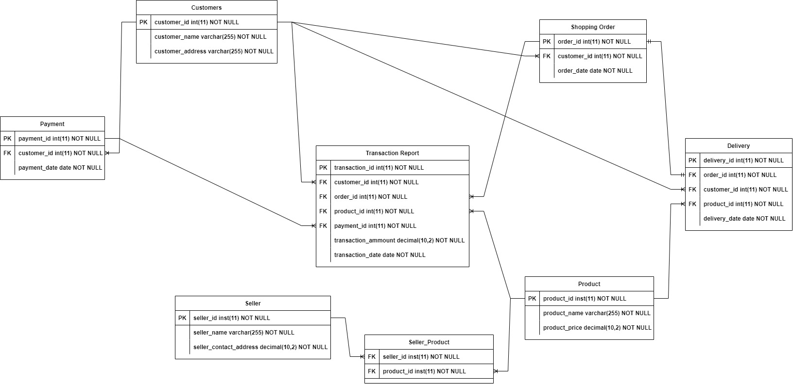MySQL was used to develop the database for the online Shopping management system and the Entity Relationship Diagram was made by using the tool <https://app.diagrams.net/>

Figure Online Shopping Management System ERD

Crow's feet notation is a commonly used graphical representation of relationships between entities in an entity-relationship diagram (ERD). In this notation, various symbols are used to represent the cardinality of a relationship, which defines the number of instances of an entity that can be associated with another entity (Odessa, 2023)**.**

In the ERD of the online shopping system, you have an entity called "Order" and another entity called "Product." The relationship between these two entities could be represented as a one-to-many relationship with a short bar and a crow's foot pointing to the "Product" entity, indicating that each order can contain many products, but each product can only belong to one order.

## **LOGICAL DESIGN AND EXPLANATION**

The logical design is the process of transforming the ERD model into a set of tables that can be used to store data in a relational database management system. The logical design for the online shopping system is shown below:

The ERD model includes eight entities: customer, product, seller, shopping order, delivery, transaction report, payment, and seller product. Each entity is represented by a rectangle, and the relationships between entities are represented by lines. The cardinality of each relationship is shown by the symbols at each end of the line (Smartdraw, 2022).

1. **Customer Table:**
   * Customer id (PK)
   * name
   * address
2. **Product Table:**
   * Product id (PK)
   * Product name
   * price
3. **Seller Table:**
   * Seller id (PK)
   * name
   * contact address.
4. **Shopping Order Table:**
   * Order id (PK)
   * customer id (FK)
   * date
5. **Delivery Table:**
   * Delivery id (PK)
   * order id (FK)
   * customer id (FK)
   * product id (FK)
   * date
6. **Transaction Report Table:**
   * Report id (PK)
   * customer id (FK)
   * order id (FK)
   * product id (FK)
   * payment id (FK)
   * amount
   * date
7. **Seller Product Table:**

* Seller id (FK)
* product id (FK)

1. **Payment Table:**
   * Payment id (PK)
   * customer id (FK)
   * date

The tables are designed to store the data for each entity, with the primary key (PK) and foreign key (FK) constraints specified where necessary. The primary key uniquely identifies each row in the table, and the foreign key establishes a relationship with another table. The attributes for each table are defined based on the information required by the system, as specified in the business rules.

The relationships between these entities are as follows:

1. Each customer can make multiple shopping orders, and each shopping order is made by only one customer.
2. Each shopping order can have multiple transaction reports, and each transaction report is related to only one shopping order.
3. Each transaction report can have only one payment, and each payment is made by only one customer.
4. Each payment can have multiple transaction reports, and each transaction report is related to only one payment.
5. Each customer can have multiple deliveries, and each delivery is related to only one customer.
6. Each order can have one delivery, and each delivery is related to only one order.
7. Each product can have multiple sellers, and each seller can have multiple products.
8. Each product can have multiple transaction reports, and each transaction report is related to only one product.

The ERD model for the online shopping system is shown above using the Crow’s Foot notation:

## **CONCLUSION**:

In conclusion, the online shopping industry has revolutionized the way businesses operate and connect with their customers. The development of online shopping management systems has made it easier for businesses to manage their online stores, streamline the purchasing process, and enhance the overall shopping experience for their customers. The use of online shopping management systems is no longer a luxury but a necessity for businesses that want to remain competitive in the digital age.

Personalized product recommendations and mobile optimization have enhanced the overall shopping experience and made it more tailored to the individual customer's needs. These features have also enabled businesses to reach a wider audience and attract new customers (TutorialsPoint, 2022).

The database is a critical component of any online shopping management system as it stores and organizes all the data related to products, customers, orders, and transactions. A robust database enables businesses to analyze customer behavior, make data-driven decisions, and improve their overall performance. By leveraging the power of a robust database, businesses can personalize their services, identify trends, and improve customer satisfaction.

As online shopping continues to evolve, the importance of effective online shopping management systems will only continue to grow. The future of online shopping will be characterized by more advanced features. Businesses that want to remain competitive will need to keep up with the latest trends and technologies to provide their customers with the best possible shopping experience. Overall, online shopping management systems are critical to the success of any online business and will continue to shape the future of e-commerce (Wikipedia, 2019).

## **BIBLIOGRAPHY**

Biscobing, J. (2019, September 11). *Entity Relationship Diagram (ERD)*. Data Management. <https://www.techtarget.com/searchdatamanagement/definition/entity-relationship-diagram-ERD>

Wikipedia contributors. (2019, March 21). *Online shopping*. Wikipedia. <https://en.wikipedia.org/wiki/Online_shopping>

Sullivan, M. (2022, July 27). *The Importance of Entity Relationship Diagrams*.

<https://blog.hubgem.co.uk/the-benefits-of-entity-relationship-diagrams>

*How to Draw Entity Relationship Diagrams*. (2020, October 2). Gliffy by Perforce. <https://www.gliffy.com/blog/how-to-draw-an-entity-relationship-diagram>

Entity*-Relationship Diagram (ERD) | How To Make a Crow’s Foot ER Diagram | Crows Foot Erd For Online Shopping*. <https://www.conceptdraw.com/examples/crows-foot-erd-for-online-shopping>

*Help and* Support*: APA - Referencing Guide: APA Style*. (n.d.). <https://libguides.murdoch.edu.au/APA#:~:text=The%20APA%20referencing%20style%20is,and%20the%20year%20of%20publication>.

“Online Shopping System.” *Student Project Guidance & Development*, 8 Nov. 2017, <https://studentprojectguide.com/php/online-shopping-system/>.

*Database Tables Schema of Online Shopping System | Projects Inventory*. 16 June 2022, <https://projectsinventory.com/database-tables-schema-of-online-shopping-system/>.

*PHP MySQL Create Table*.

<https://www.w3schools.com/php/php_mysql_create_table.asp>.

*What Are the Advantages and Disadvantages of Online Shopping*. <https://www.tutorialspoint.com/what-are-the-advantages-and-disadvantages-of-online-shopping>.

“Online Shopping System.” *Student Project Guidance & Development*, 8 Nov. 2017, <https://studentprojectguide.com/php/online-shopping-system/>.

*Database Tables Schema of Online Shopping System | Projects Inventory*. 16 June 2022, <https://projectsinventory.com/database-tables-schema-of-online-shopping-system/>.

*PHP MySQL Create Table*.

<https://www.w3schools.com/php/php_mysql_create_table.asp>.

Tutorials24x7. “Guide To Design Database For Online Shopping Cart In MySQL.” *Tutorials24x7*, <https://mysql.tutorials24x7.com/blog/guide-to-design-database-for-shopping-cart-in-mysql>